**2. Git-HOL**

**2. Create a “.log” file and a log folder in the working directory of Git. Update the .gitignore file in such a way that on committing, these files (.log extensions and log folders) are ignored.**

**· Setting up Git environment**

**· Integrate notepad++ as a default editor**

**· A Git repository in the local system and a remote repository in GitLab**

**Output**

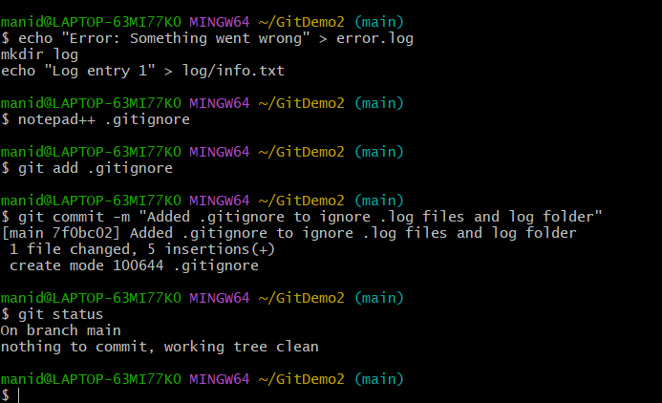

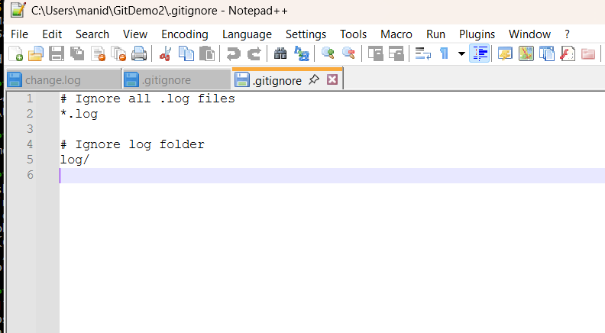d log folders) are ignored